 **NORTH SOUTH UNIVERSITY**

School of Engineering & Physical Sciences

EEE-111

Analog Electronics I

Project topic: USB Mobile Charger

|  |  |
| --- | --- |
| Submitted To:  Dr. Sharnali Islam  Assistant Professor  Department of Electrical  & Computer Engineering | Submitted By:  Abdullah Al Mamun  1511753642  Mustafizur Rahman  1510078042  Sujit Debnath  1511378642 |

Section-04, Group-08

Submitted: Tuesday, 18th April, 2017

TABLE OF CONTENT

1 Introduction 3

1.1 Project Description 3

1.2 Block Diagram 3

2 Design 3

2.1 Circuit Diagram 3

2.2 Justification of choice of this circuit 4

3 Implementation 4

3.1 Procedures 4

3.1.1 Step down AC voltage 4

3.1.2 Rectification 4

3.1.3 Filtration 4

3.1.4 Voltage Regulation 4

3.2 Equipment and Cost 5

3.3 Difficulties faces 5

4 Future Recommendations 5

# Introduction

## Project Description

This project is all about a cell phone charger which can charge any kind of mobile phone. Mobile phones generally charge with 5V regulated DC supply. So basically, we are going to build a 5V regulated DC supply from AC supply which is 220V.

For building a 5V regulated DC supply, our circuit should be consisted of a step-down Transformer, a full wave bridge rectifier and a 5V voltage regulator IC (7805). We can divide this circuit into several small parts. Such as, step down AC voltage, rectification, filtration, voltage regulation. After all of these, our output will be 5V 1.5A DC signal which can charge almost all mobile headset.

## Block Diagram

Block diagram of the project USB mobile charger circuit is shown in below,

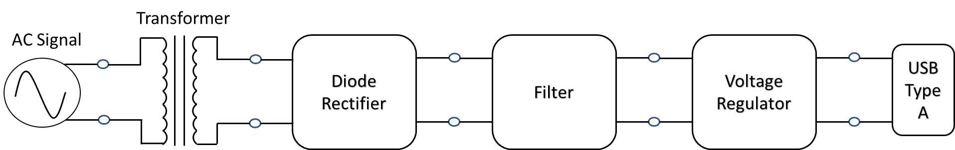

Figure Block Diagram of the project

# Design

## Circuit Diagram

USB mobile charger circuit diagram is given below,

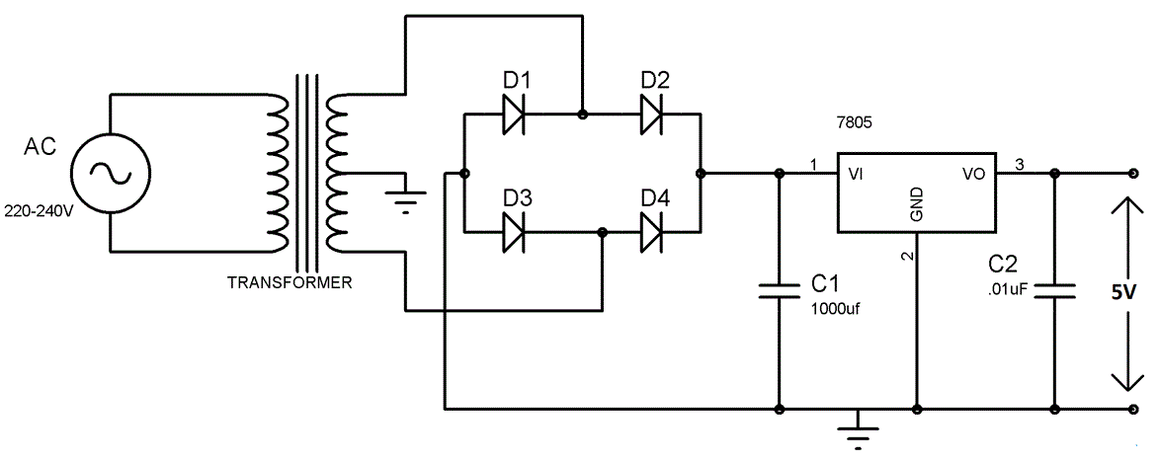

Figure USB cell phone charger circuit

## Justification of choice of this circuit

For the implementation of the project, we choose this circuit diagram, which has several reasons to choose. This circuit build using transformer, diode, capacitor and voltage regulator. Basically, it consists a step-down transformer, full wave bridge rectifier, filtration of DC signal, voltage regulation, and all of these topics is covered within our EEE111 Analog Electronics I course materials. For this reason, we selected this circuit.

# Implementation

## Procedures

For the simplicity of the implementation, we divided this circuit into several parts. Such as, step down AC voltage, rectification, filtration, voltage regulation.

### Step down AC voltage

Since we need to convert 220V AC into a 5V DC, first we have to use step-down transformer to reduce such high voltage. So, we set 12V 3A step-down transformer on the breadboard as shown in circuit diagram, which convert 220V AC to 12V AC.

### Rectification

Now we have to convert the AC signal to DC signal. That’s why we set the full wave bridge rectifier using 4 silicon diodes on the breadboard as shown in the circuit diagram, which convert 12V AC to 12V DC.

### Filtration

The output after the Rectification is not a proper DC, it has a very high ripple factor. For this reason, we have to use Capacitor. So, we set a 1000µF capacitor on the breadboard which reduce the high ripple factors and smoothen DC signal.

### Voltage Regulation

Now we have to use a voltage regulator IC 7805 to provide a regulated 5V DC. Also, capacitor of 0.01µF should be connected to the output of the 7805 to eliminate the noise, produced by transient changes in voltage. So, we set all of these on breadboard as shown in circuit diagram.

## Equipment and Cost

|  |  |  |  |  |  |
| --- | --- | --- | --- | --- | --- |
| # | Component Details | Specification | Quantity | Rate(Tk.) | Amount(Tk.) |
| 1. | Step down Transformer | 12Volt 3A | 1 piece | 198 | 198 |
| 2. | p-n Junction silicon diode | 1N4007 | 4 pieces | 1 | 4 |
| 3. | Capacitor | 0.01µF | 1 piece | 2 | 2 |
| 1000 µF 25V | 7 | 7 |
| 4. | Voltage Regulator | LM7805 | 1 piece | 8 | 8 |
| 5. | Breadboard | - | 1 piece | 116 | 116 |
| 6. | Plug, wires & data cable | - | - | - | 60 |
| Total Costs | | | | | 395 |

## Difficulties faces

We faced our first difficulties when we tried to put the AC signal on breadboard as an input. Since we didn’t have any signal generator, we had to use the home electricity line. That’s why, we brought the plug, wires and connected them together. Finally, we set that input line with transformer and breadboard.

Another simple difficulty was with the USB type A connector. This connector couldn’t set on breadboard for its weird pin head. To solve this issue, we had to cut the data cable and connect it to the breadboard.

# Future Recommendations

This mobile charger circuit can be modified in such a way that it can charge more than one device at the same time. Also it can be modified such that it can do multiple tasks. Such as, it can charge mobile device and run a motor parallel to each other.